15. Data Loader Insert, Update, Upsert, External ID - 15 March 2022

Operations

1] Insert

2] Update

3] Upsert

4] External Id

5] Export

6] Export All

7] Delete

8] Hard Delete

1] Insert

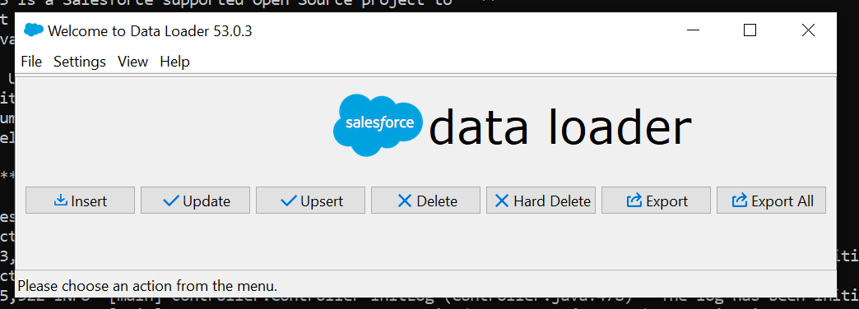

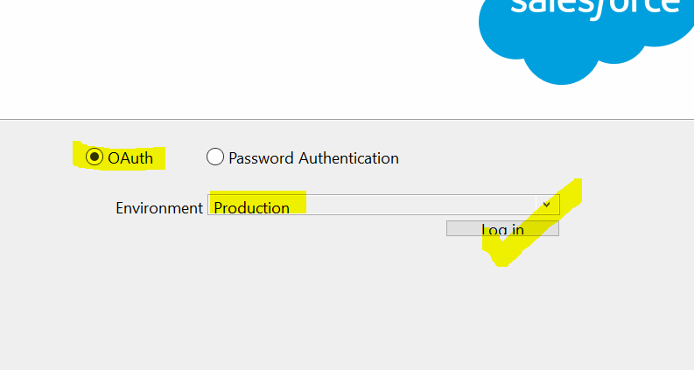

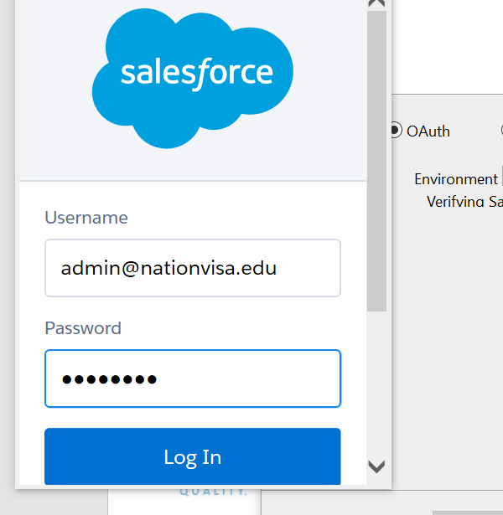

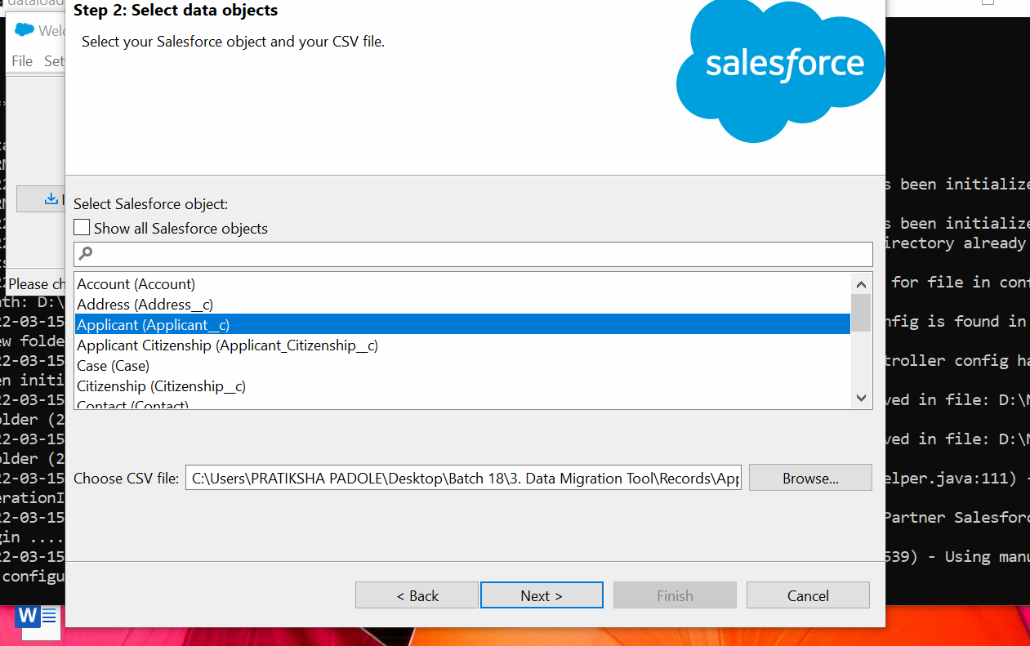

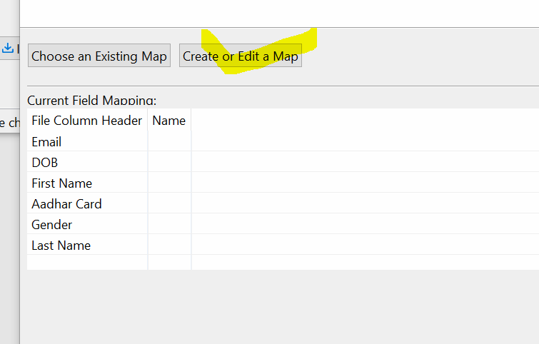

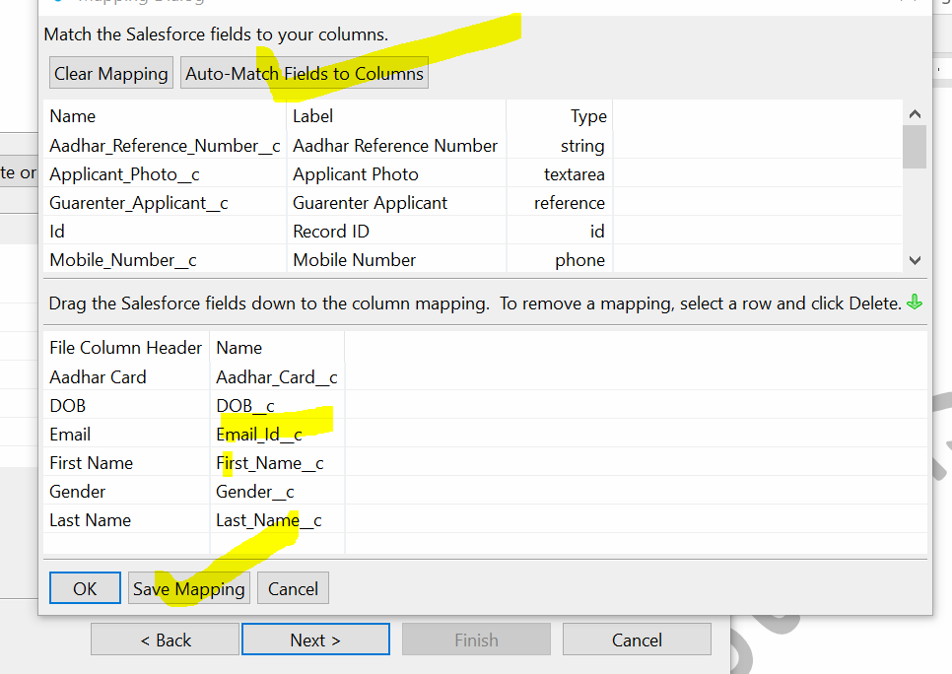

2] Update

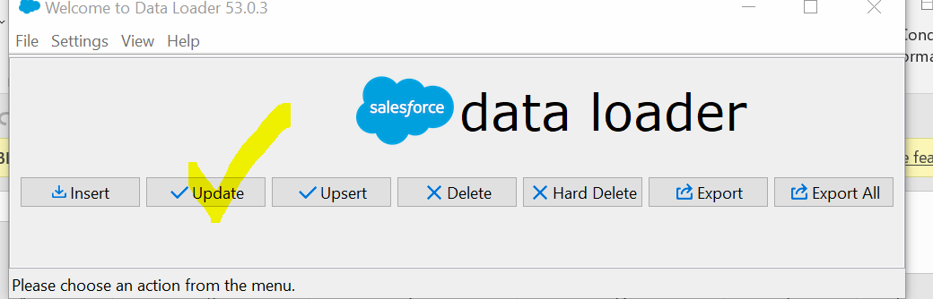

3] Upsert

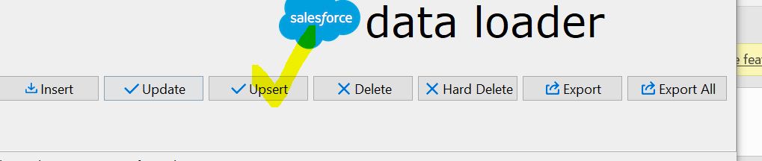

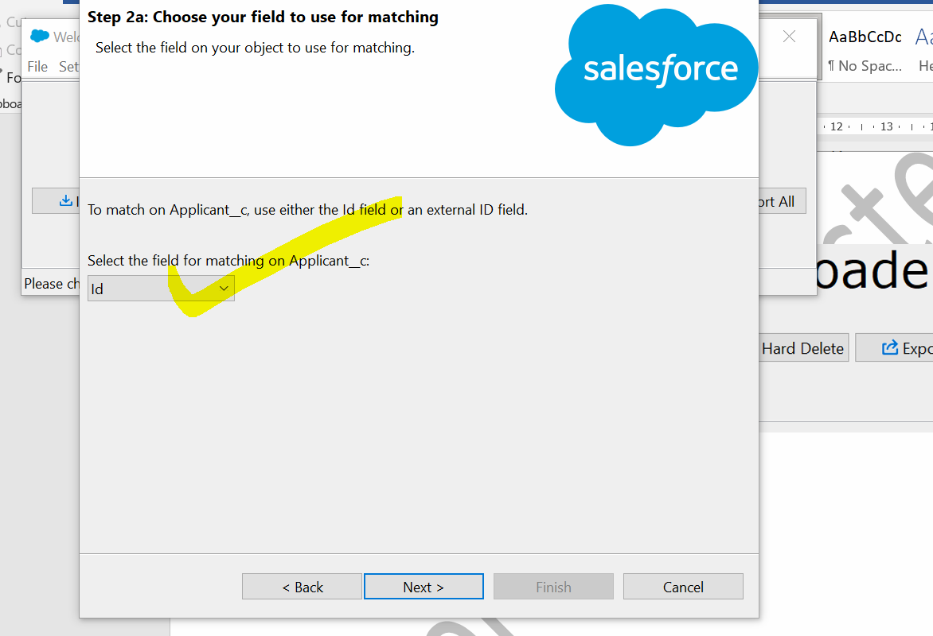

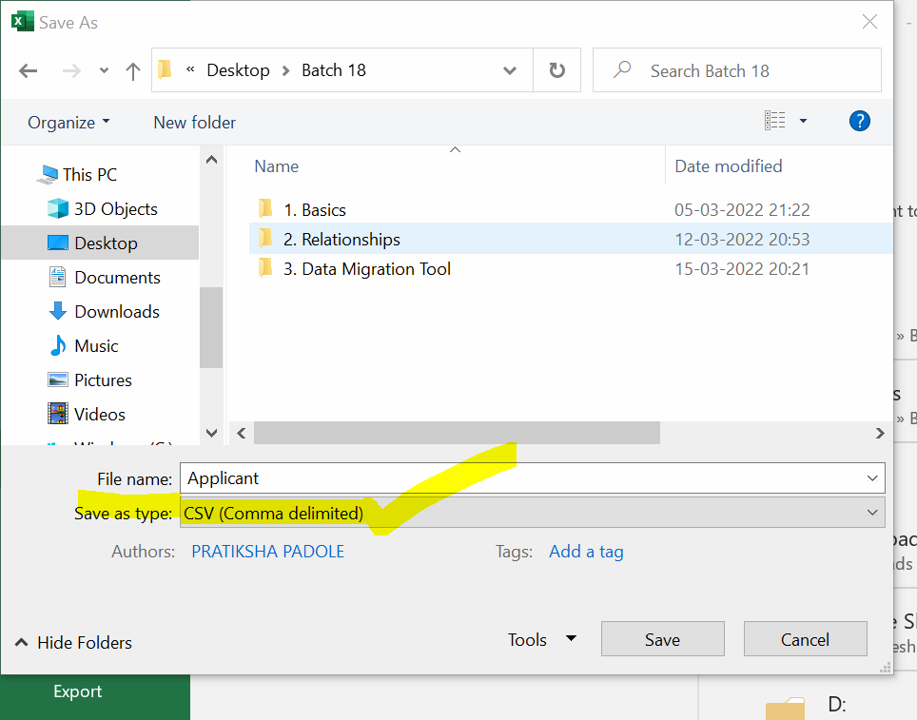

4] External Id

When we want to update CSV File Records and If we don’t have Record ID, then we make salesforce object field as external Id (It should be a unique) and we map this external id field with CSV Field.

OR

An external ID is **a custom field that has the External ID attribute, meaning that it contains unique record identifiers from a system outside of Salesforce**. When you select this option, the Data Import Wizard detects existing records in Salesforce with external IDs that match those values in the import file.

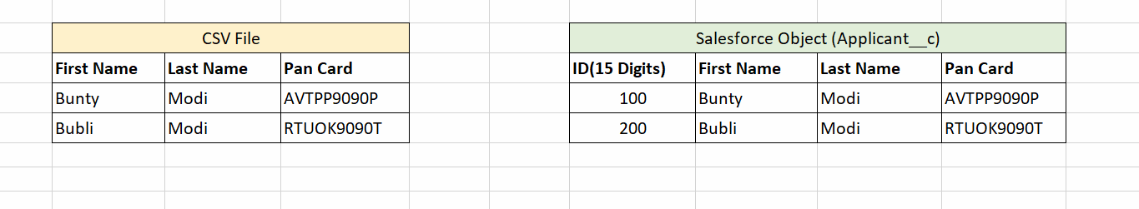



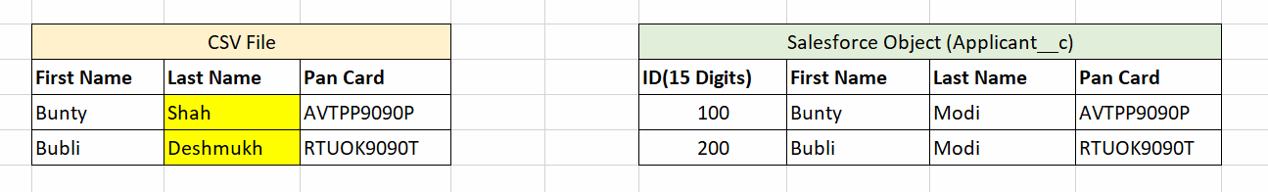



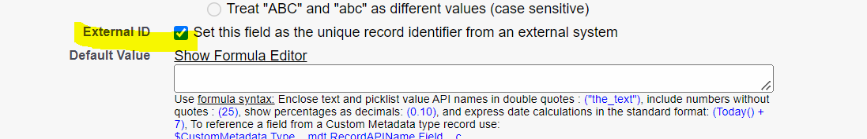

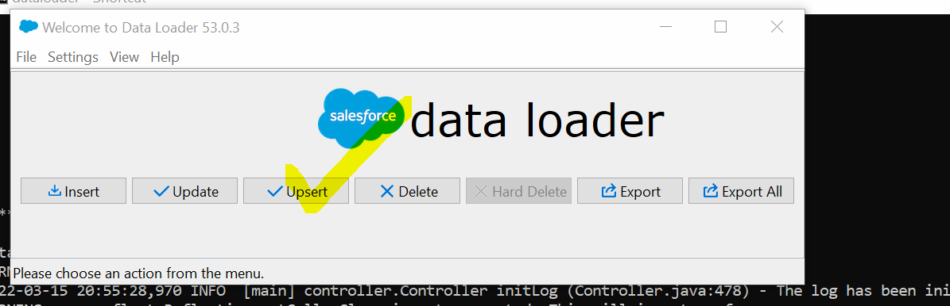

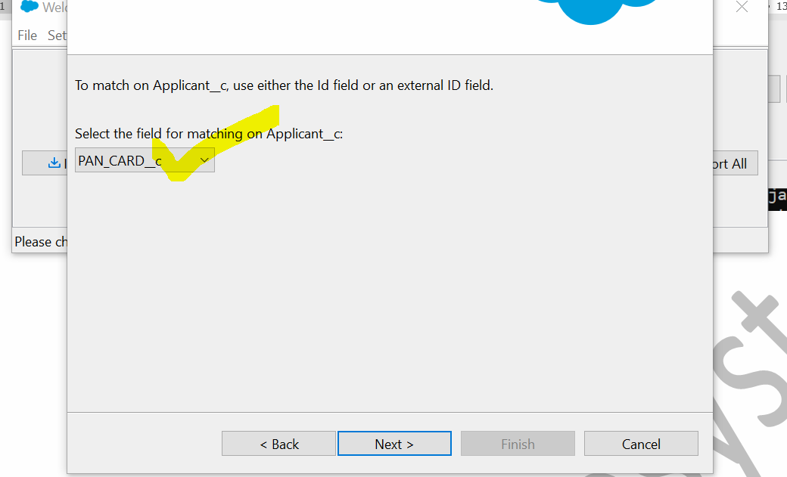

Maximum External ID = 25 (Before it was 07)